**LAPORAN PRAKTIKUM LATIHAN**

Pemrograman Berbasis Web

Pertemuan 04



Oleh :

NAMA : FARAH TRI MAHARDINI

NPM : 4522210042

Dosen:

**Adi Wahyu Pribadi ,S.Si.,M.Kom**

**S1-Teknik Informatika**

**Fakultas Teknik Universitas Pancasila**

**2023/2024**

Latihan 1

Source Code

package main

import "fmt"

type person struct {

    name string

    age int

}

func main() {

    fmt.Print(person{"Bob", 20})

    fmt.Println(person{name: "Alice", age: 30})

    fmt.Println(person{name: "Fred"})

    fmt.Println(&person{name: "Ann", age: 40})

    s := person{name: "Sean", age: 50}

    fmt.Println(s.name)

    sp := &s

    fmt.Println(sp.age)

    sp.age = 51

    fmt.Println("sp.age: ", sp.age)

    fmt.Println("s.age: ", s.age)

}

Hasil running

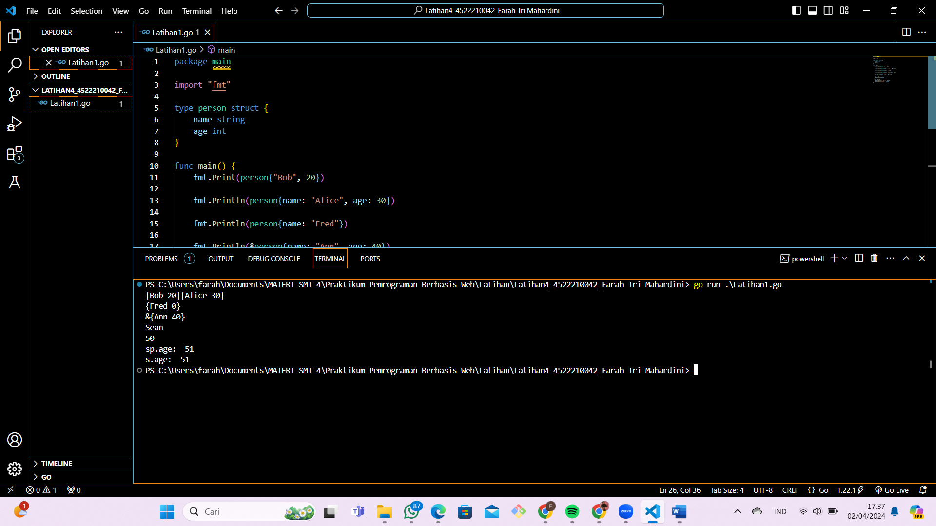

Latihan 2

Source code

package main

import "fmt"

type Customer struct {

    Name, Address string

    Age int

}

func (customer Customer) sayHello(name string) {

    fmt.Println("Hello", name, "my name is", customer.Name)

}

func main() {

var eko Customer

fmt.Println(eko)

eko.Name = "Eko Kurniawan"

eko.Address = "Indonesia"

eko.Age = 30

fmt.Println(eko)

fmt.Println(eko.Name)

fmt.Println(eko.Address)

fmt.Println(eko.Age)

joko := Customer{

    Name: "Joko",

    Address: "Indonesia",

    Age: 30,

}

fmt.Println(joko)

budi := Customer{"Budi", "Indonesia", 30}

fmt.Println(budi)

    budi.sayHello("Agus")

    eko.sayHello("Agus")

    joko.sayHello("Agus")

    }

Hasil Running

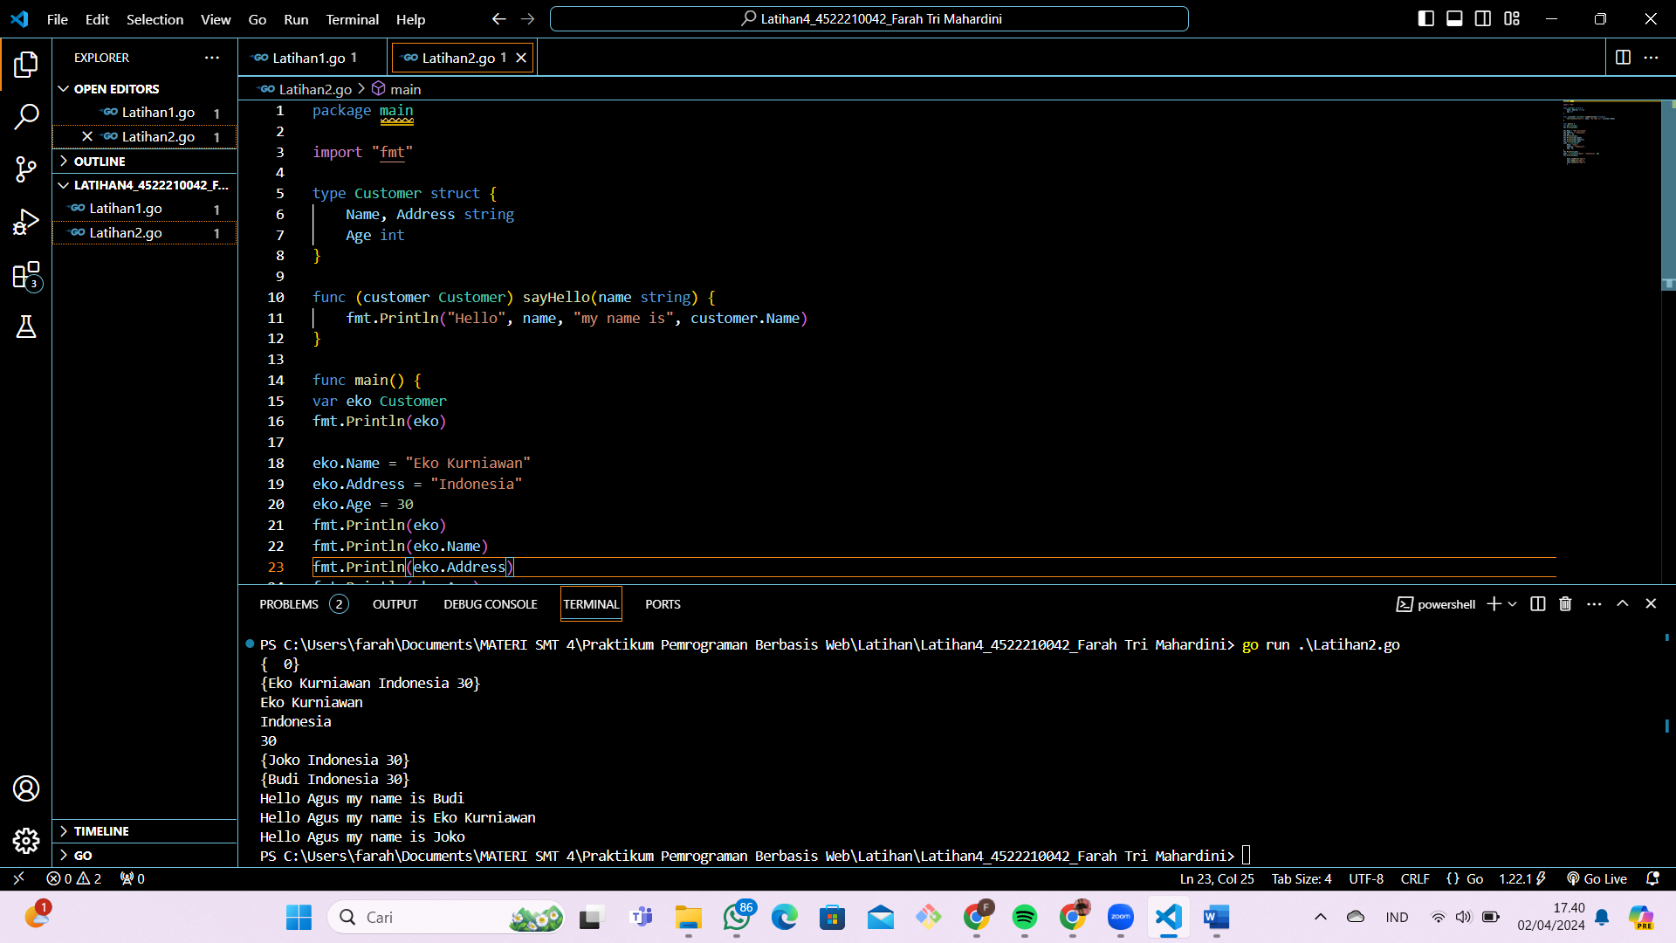

LINK GITHUB